Q1: Data Cleaning and Loading
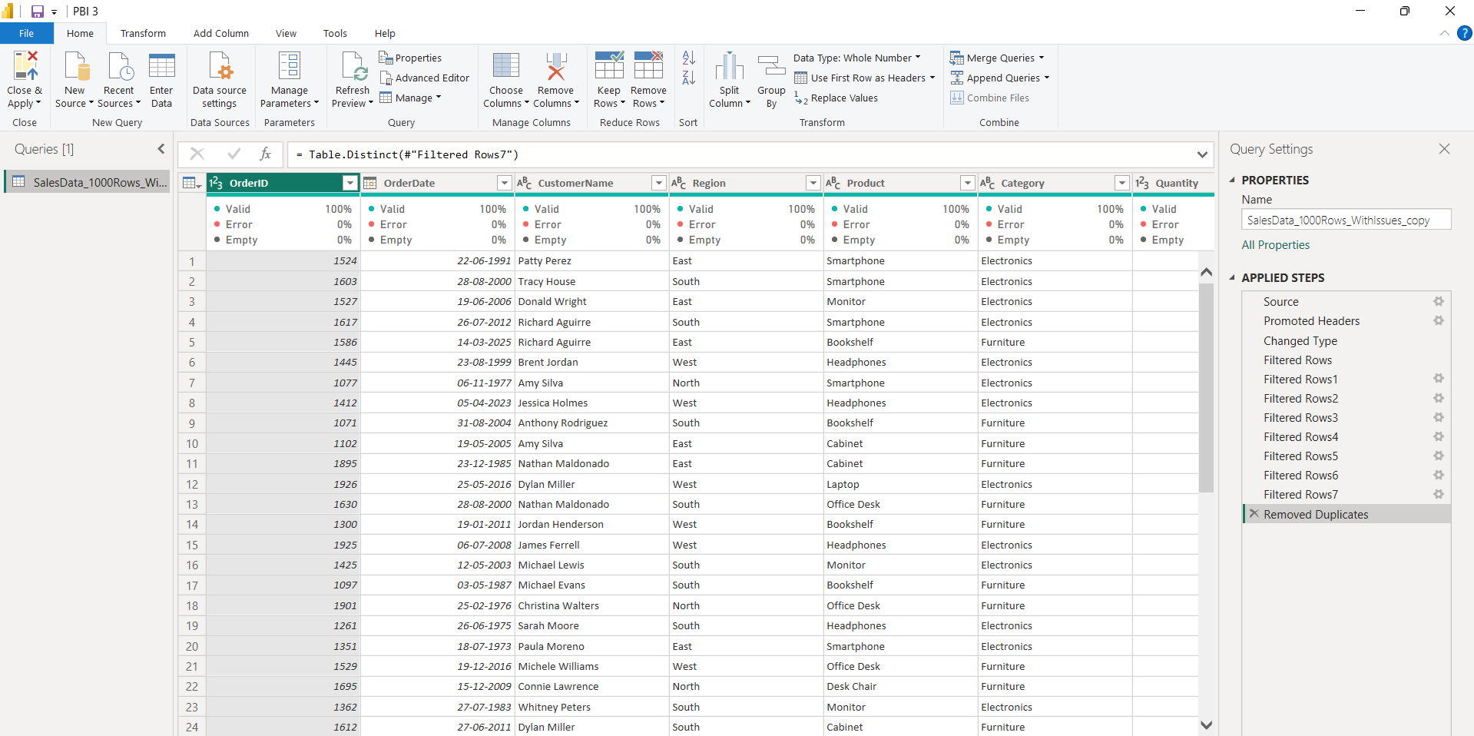

Q2: Visualizations and Insights

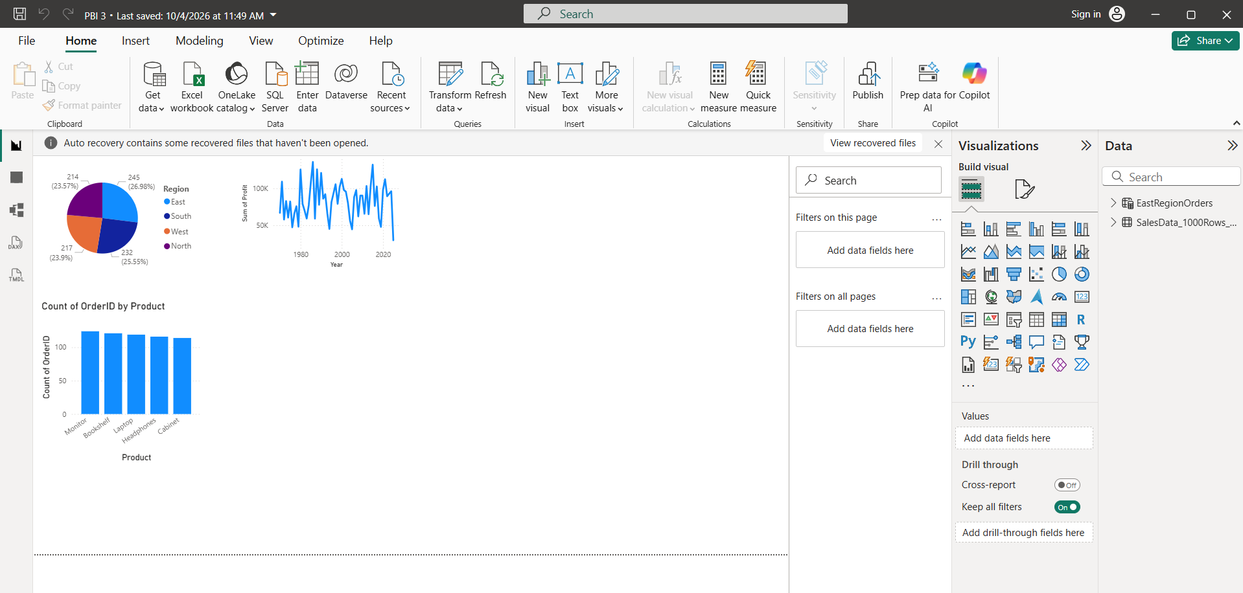

Q3: DAX Calculations
